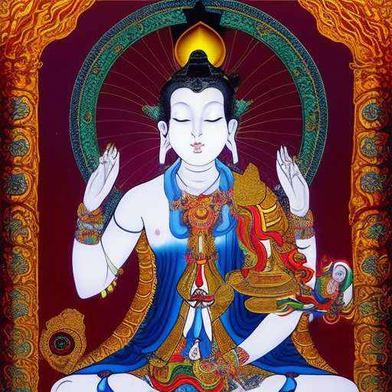
LONGS FOR RAINBOWS

Come back to Holy Emotional Forms and become a Bodhisattva
Ahura Mazda’s Yin sweetly smiles like a waning Cheshire
By pools of flooding darkness stands Noah
He longs for rainbows and aromas of fresh lands
The Merciful Advocate makes light yokes of crosses
Effulgent Queen of White Fire & Gold
Victorious over Hermes & his restless flight
Still with Beatific Vision and Conflagrations of Blessed Assurance
Serene, Orphic, Regal, True, Elevated Reticence
Branches of Virtuous, flickering pink flames

